GLA University


TOPIC: MINI PROJECT REPORT ON VOLUNTEER MANAGEMENT SYSTEM
Submitted to:

Faculty Name: Mr. Akash Kumar Choudhary
Technical Trainer

Submitted By:

Nitin Sharma (2215001187)
Rishabh Gupta (2215001444)
Rohit Rawat (2215001492)
Sachin Gola (2215001508)
Shivam Rai (2215001670)

DECLARATION
The work for this project will be finished by our team members, we, the undersigned, thus declare. Particularly important project areas are within the purview of the following people:

Sachin: Volunteer List Management
Rohit: Frontend
Shivam: Backend connectivity and MongoDB
Rishabh: Event list
Nitin: Attendance management

We pledge to contribute to this effort equally and to work with integrity and teamwork throughout.

Acknowledgement

I would like to sincerely thank everyone who helped me during the Volunteer Management System development process.
First and foremost, I would want to express my gratitude to my project manager and mentors for their crucial advice and support, which enabled me to successfully complete this project despite its hurdles. Their opinions and thoughts were quite helpful in determining how things turned out in the end.
I would also like to express my gratitude to my teammates for their hard work and cooperation, which contributed to the development process's success. Their assistance and contributions were crucial to us reaching the project's objectives.
Lastly, I would want to thank my family and friends for their continuous support and understanding during the duration of this effort. Their motivation kept me focused and inspired.

Certificate

This is to certify that the project entitled ‘VOLUNTEER MANAGEMENT SYSTEM’ is a Bonafide work done by –
- Nitin Sharma (2215001187)
- Rishabh Gupta (2215001444)
- Rohit Rawat (2215001492)
- Sachin Gola (2215001508)
- Shivam Rai (2215001670)
In satisfactory manner as a partial fulfilment for the course of B. TECH (Computer Science and Engineering)- V for the session 2024-25, has been carried out under my direct supervision and guidance

Project Mentor Project Head

Index
S.NO | Topic
1 | Introduction/Abstract/Title
2 | System Requirements
3 | Hardware Requirements
4 | Front End and Back End
5 | Idea
6 | Objective
7 | Module Description
8 | Availability
9 | Bibliography
10 | References

Introduction
The Volunteer Management System is an advanced web tool designed to simplify how organizations and events handle volunteer coordination. This platform enables administrators to efficiently organize volunteer activities, monitor attendance, assign tasks, and assess volunteer performance, all from a single dashboard. Volunteers can easily sign up, manage their schedules, and track their responsibilities.

Built with a React-based front end and a Node.js back end, the system guarantees fast, scalable performance. Key features include task assignments, attendance monitoring, automated scheduling, and comprehensive volunteer reporting. By optimizing volunteer management, the platform enhances productivity while reducing the administrative burden.

Additionally, the system offers tools for budget tracking, guest list organization, event planning, and sending reminders, providing a holistic solution for volunteer and event management.

About the Project:
The purpose of the Volunteer Management System is to make it easier for organizations and events to manage and coordinate volunteer labour. The system is designed to be scalable and seamless, with React on the front end and Node.js on the back end. While volunteers may easily manage their calendars and stay updated with notifications and reminders, administrators can assign assignments, track attendance, and monitor volunteer performance.

Task assignment, attendance monitoring, real-time updates, and comprehensive reporting are some of the key elements that are intended to lessen administrative work while enhancing volunteer participation. Because of its scalable architecture, the platform may be used by organizations of any size.
Primary Reason to choose this project:
Purpose of the Project:
The Volunteer Management System was developed to resolve challenges organizations face in efficiently managing volunteers.
Issues with Manual Processes:
Manual systems often result in confusion, inefficiency, and challenges in tracking volunteer activities.
Primary Objectives:
- Increase volunteer participation
- Reduce the administrative workload
- Improve communication through automation
Skills Development:
- Provides hands-on experience with full-stack web development using React and Node.js
- Addresses a real-world problem that affects various organizations

Scalability and Adaptability:
- The system’s scalable architecture allows for customization to fit the needs of different volunteer-based efforts, making it a versatile and valuable tool.

The Main Objective of the Project:
The primary aim of the Volunteer Management System project is to create a centralized platform that simplifies the process of organizing, overseeing, and tracking volunteers. The system is designed to reduce the administrative burden on organizations by automating essential tasks such as volunteer registration, task allocation, attendance tracking, and performance evaluation. It also enhances communication by delivering reminders and notifications, ensuring volunteers remain informed and engaged.

With its scalable design, the platform can support organizations of all sizes and adapt to the specific needs of various volunteer-driven projects. Ultimately, the system seeks to boost volunteer engagement, streamline operations, and provide a seamless experience for both administrators and volunteers.

Scope of the Project:
The Volunteer Management System project's primary goal is to establish a centralized platform that makes organizing, supervising, and monitoring volunteers easier. In order to lessen the administrative load on companies, the system attempts to automate crucial processes such volunteer registration, task assignment, attendance tracking, and performance monitoring. It also improves communication by sending out reminders and notifications, which keeps volunteers informed and involved. Because of the platform's scalability, it can accommodate groups of varied sizes and adjust to meet the unique requirements of various volunteer-driven initiatives. The ultimate objectives are to increase volunteer participation, streamline operations, and offer administrators and volunteers a seamless experience.
Working Methodology of the Project:
To ensure flexibility and continuous improvement, the Volunteer Management System will be developed using an agile methodology. The project will be broken down into several key phases:
- Needs Assessment: Identifying the requirements of both volunteers and administrators.
- Design: Creating an intuitive UI/UX using React for easy navigation.
- Development: Implementing core features using MongoDB for data storage and Node.js for the backend.
- Testing: Conducting unit and integration tests to ensure all functionalities work as intended.
- Deployment: Launching the system in a scalable, cloud-based environment.
- Iteration and Feedback: Collecting user feedback to enhance the system and introduce new features over time.

Details About the Hardware and Software

System Requirements:
Supported Operating Systems:
◦Windows 10 or later
◦macOS Catalina (10.15) or later
◦Linux (Ubuntu, Fedora, etc.)

Software Required:
- For Frontend Development:
◦ React.js
◦ Node.js (for development environment setup)
◦ Vite (for build process) ◦ Visual Studio Code (for coding)
- For Backend Development:
◦ Node.js
◦ MongoDB
◦ Express.js (for API development)
◦ Postman (for API testing)
◦ NPM/Yarn (for package management)
Hardware Requirements:
- For Android Studio and IntelliJ:
◦ Processor: Intel Core i5 or AMD Ryzen 5 or better
◦ RAM: Minimum 8GB (16GB recommended)
◦ Storage: 256GB SSD or higher
◦ Graphics: 1280x800 minimum screen resolution
- For Eclipse IDE:
◦ Processor: Intel Core i3 or AMD equivalent ◦ RAM: Minimum 4GB (8GB recommended)
◦ Storage: 100GB HDD/SSD
◦ Graphics: 1024x768 minimum screen resolution

Listing Out Testing Technology
- Frontend Testing:
◦ Jest (for unit and snapshot testing)
◦ React Testing Library (for UI testing)
◦ Cypress (for end-to-end testing)
- Backend Testing:
◦ Mocha or Jest (for unit and integration testing)
◦ SuperTest (for API testing)
◦ Postman (for manual API testing)
Frontend and Backend:
Frontend:
- React.js for building UI components
- Vite as the build tool
- Axios for making API calls
- CSS or styled-components for styling
- React Toastify for user notifications
Backend:
- Node.js and Express.js for building REST APIs
- MongoDB for database storage
- Mongoose for database schema modelling
- JWT (JSON Web Tokens) for authentication
- Node mailer for email notifications

Module Description
The Volunteer Management System is divided into several modules, each responsible for specific functionalities:
- User Management Module: Handles user registration, authentication, and profile management for both administrators and volunteers.
- Task Management Module: Facilitates task creation, assignment, and tracking, allowing administrators to allocate tasks to volunteers based on availability and skills.
- Attendance Tracking Module: Records volunteer attendance for events and tasks, providing insights into participation and engagement.
- Notification Module: Sends reminders and notifications to volunteers about upcoming tasks, deadlines, and events to ensure smooth communication.
- Reporting Module: Generates reports on volunteer activities, attendance, and performance metrics, aiding administrators in evaluating engagement and effectiveness.

Code Pages wise and their working screenshot
File Structure:
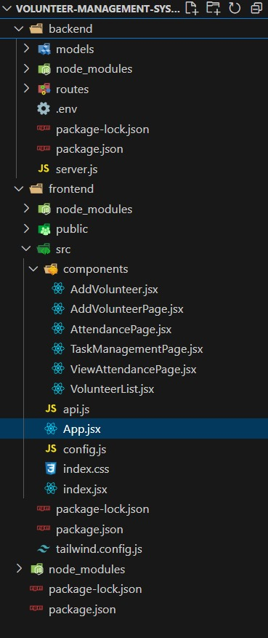

Frontend Running:
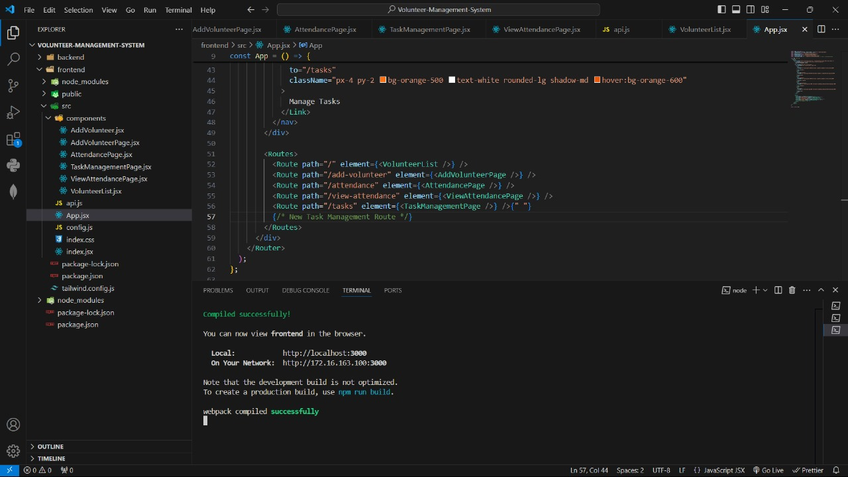
Backend Running:
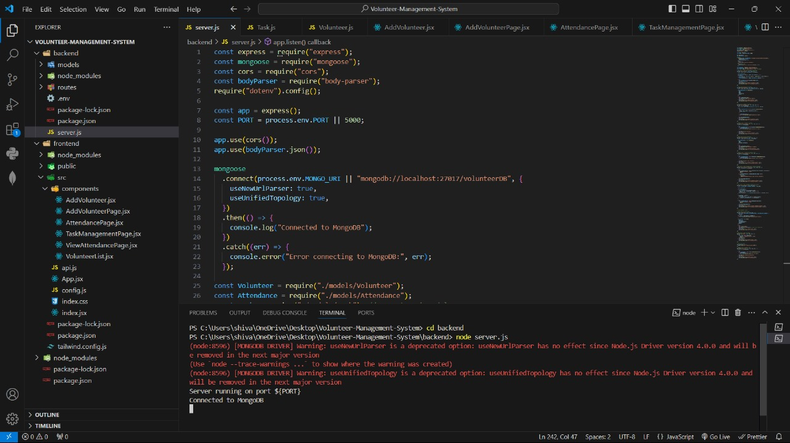

Code Snippets:

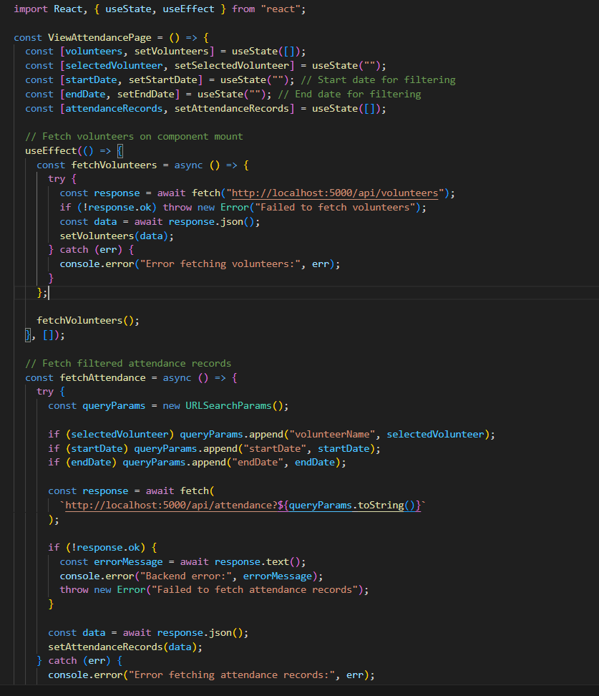
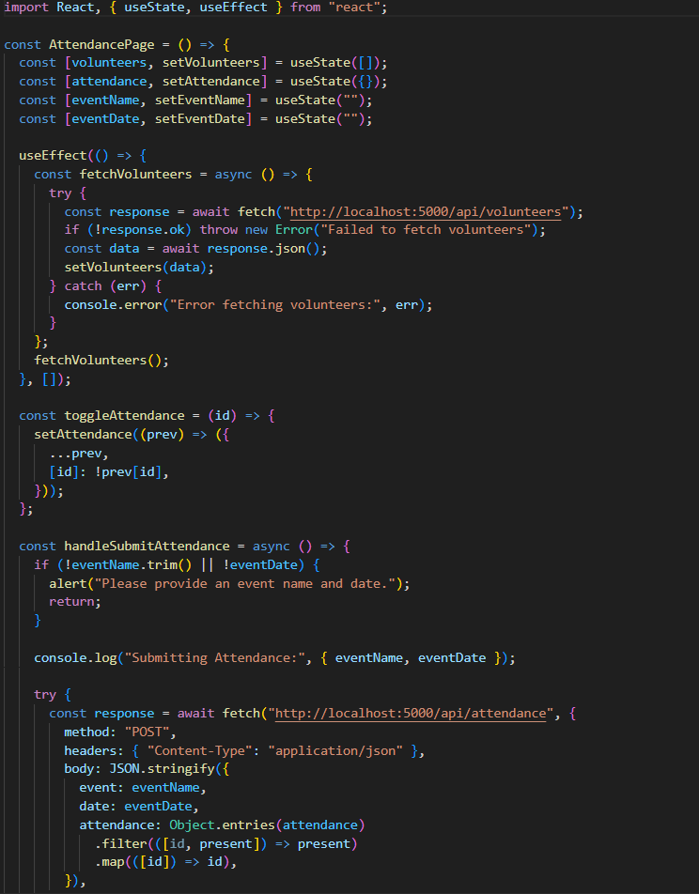
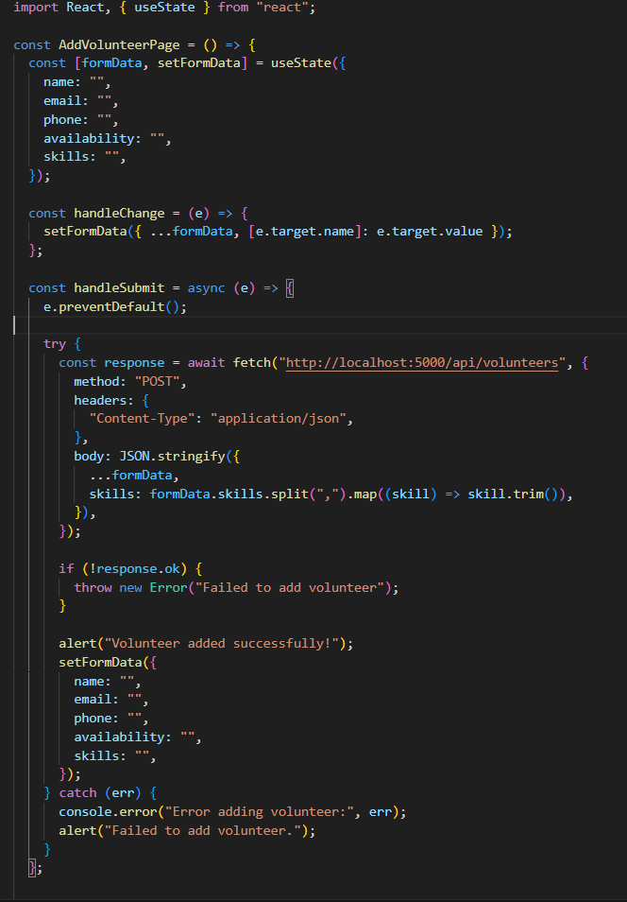
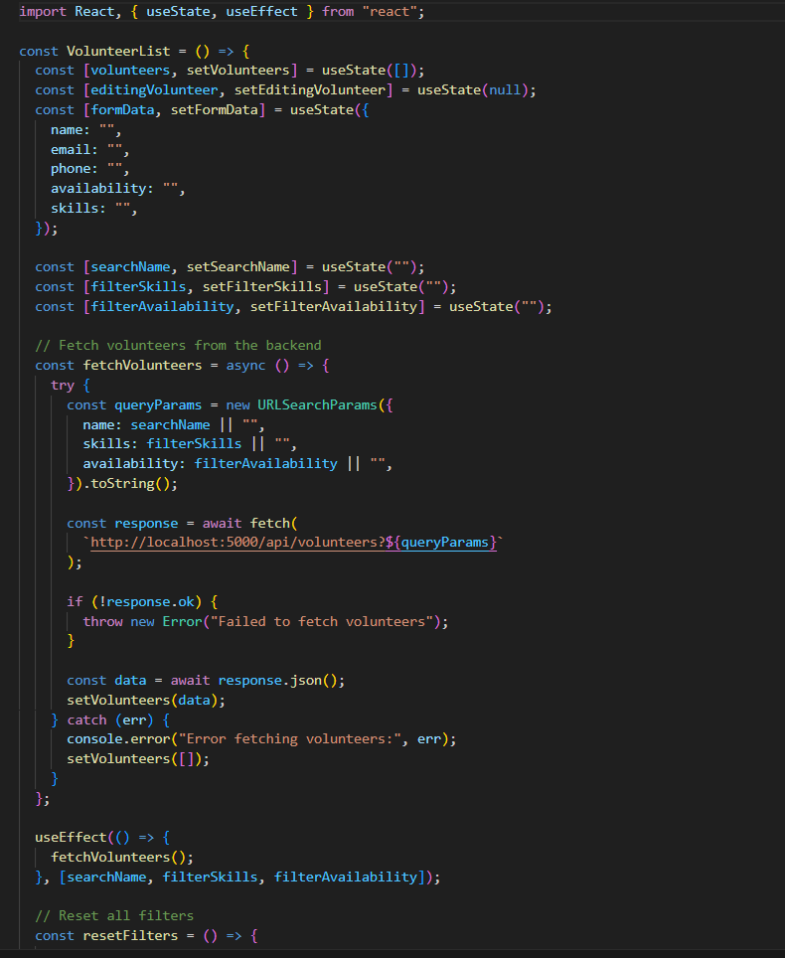

Working Website Snippets:

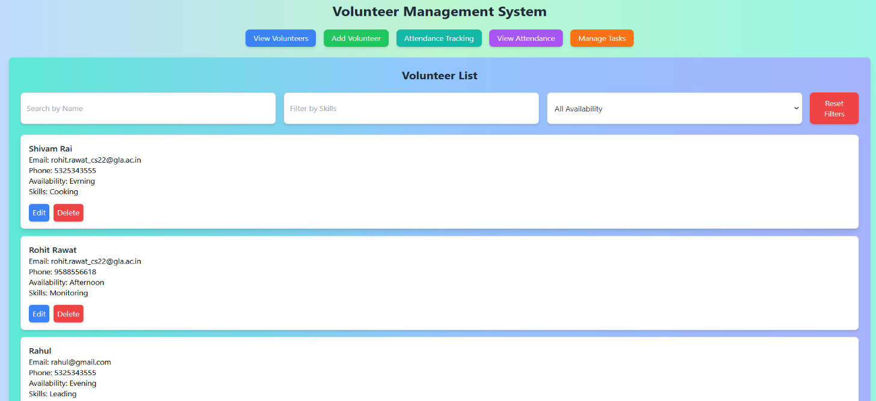

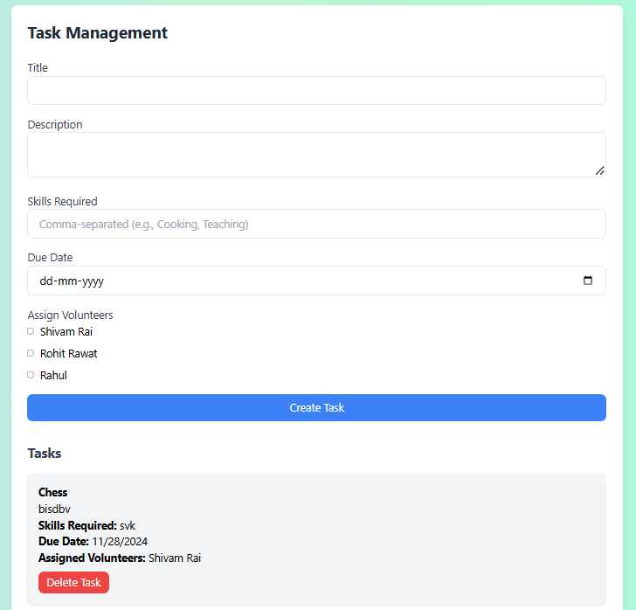
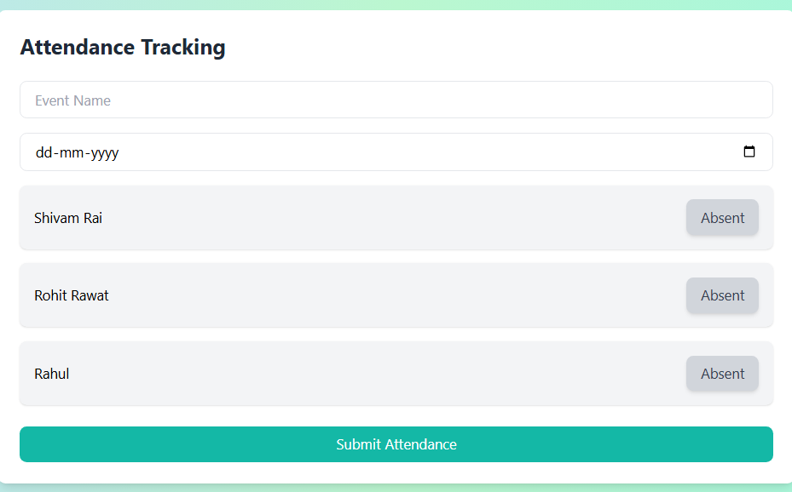
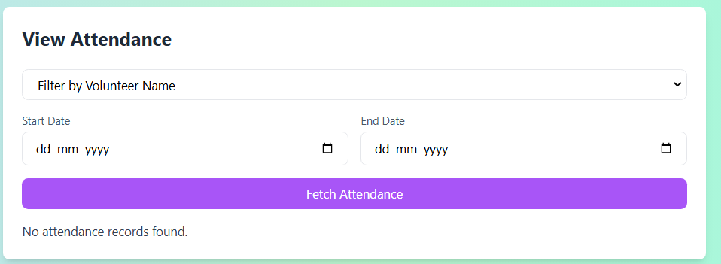
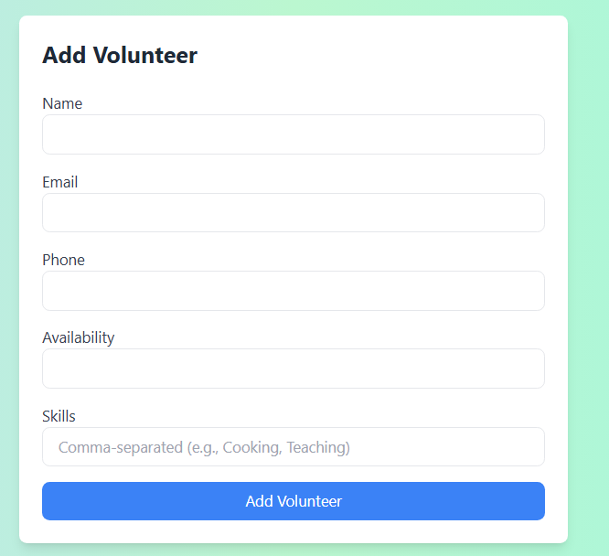
References

- Web Resources:
◦ W3Schools. (n.d.). HTML, CSS, JavaScript, and SQL Tutorials.
Retrieved from https://www.w3schools.com
◦ Mozilla Developer Network. (n.d.). Web Development Documentation. Retrieved from https://developer.mozilla.org

- Documentation:
◦ React Documentation. (n.d.). Retrieved from https://reactjs.org/docs/ getting-started.html
◦ Node.js Documentation. (n.d.). Retrieved from https://nodejs.org/en/ docs/
◦ MongoDB Documentation. (n.d.). Retrieved from https:// docs.mongodb.com/

- Tools and Technologies:
◦ Vite. (n.d.). Retrieved from https://vitejs.dev/
◦ Postman. (n.d.). Retrieved from https://www.postman.com/

